Tomorrows success begins today.
July 2023
A large print version of this document is available if requested.

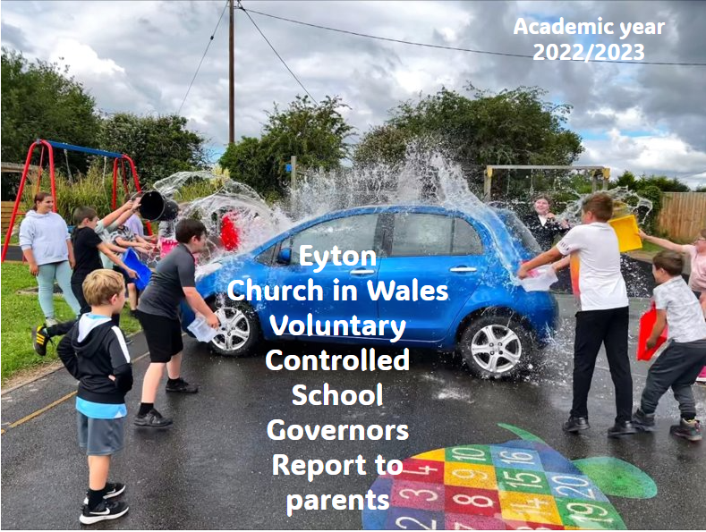
This report is intended to update you on how we, the governors, have carried out our duties. The report includes lots of information about school, and we welcome feedback and questions.

The governing body were:
Name | By whom appointed
Mrs. S Jones(chair) | Local authority
Mrs. J Ayee | Local authority
Mrs. L Whitgreave | Head teacher
Revd Canon S M Huyton | Exofficio foundation governor
Mrs L Lambert | Community governor
Mrs R Hughes | Parent governor
Mr C Long | Parent governor
Mrs R Brierley | Parent governor

Chair of governors: Mrs. S Jones chair@eytion-pri.wrexham.sch.uk
Vice chair: Mrs. J Ayee
Clerk: Ms A Gillespie, correspondence should be addressed to the
Chair of governors, Eyton school, Bangor road, Eyton LL130YD
Meeting dates
Year and term | Eyton church in Wales VC school  2022/2023 governing body meetings | Date/time
2022 | governing body meetings | 05/10/2022
2023 | governing body meetings | 09/02/2023
2023 | governing body meetings | 07/03/2023
2023 | governing body meetings | 17/05/2023
2023 | governing body meetings | 04/10/2023

Next election of parent governors
Termly monitoring and pupil progress with national tests for reading, math procedural and math reasoning tests were done in December 2022 and repeated in May 2023. New staff training for the new curriculum and assessment began in March 2022 has continued.

Summary of duties carried out this year:
Curriculum and education
Governor committees:  - Election of chair and vice chair  - Election of new governors  - Election of sub committees and terms of reference  - Appointment of governors with specific responsibilities  - Register of governor’s business interests  - Governor training  - Governor appointments and induction/mentoring of new governors | Moving Eyton forward  - Finance-budget and audits  - Head teacher’s reports  - GDPR  - Policies in line with review cycle  - Self-review and targets  - Pupil and staff absences  - Organization of classes  - Additional learning needs  - Welsh language  - Annual report to parents  - Monitoring role  - Health and safety in school

At Eyton school there are 2.5 classes:
We are currently 3 classes in the morning and 2 in the afternoon. I teacher is teaching years 3-4 in the morning and then 3-6 in the afternoon.
Early years consisting of early entitlement, nursery, reception, year 1 and year2.
Class teacher –Miss Jesson
Supported by Miss Madison and Mrs. Jones
The new curriculim has now been introduced throughout the school. The school has a child-led four purpose display in the entrance hall, with the curriculum based on the four purposes.
The curriculum is being planned around the 6 areas of learning (AOL)
Years 3 and 4 mornings
Class teacher- Mr Pugh
Years 5 and 6 mornings
Class teacher- Mrs. Hughes
Years 3,4, 5 and 6 afternoons
Class teacher Mr. Pugh supported by Mrs. Whitgreave and Mrs. Davies

Staffing:
Staff member | Role
Mrs L whitgreave | Head teacher
Miss. S Jesson | Teacher-early years
Mr Pugh | Teacher- years 3 and 4
Mrs H Hughes | Teacher-years 5 and 6
Mrs K Collins | Teacher
Ms E C Jones | Teaching assistant
Mrs J Davies | Teaching assistant
Miss M stella | Teaching assistant
Mrs V Moore | Secretary
Mrs V Moore | Lunch time assistant
Mrs H Durnell | Lunch time assistant
Mr M Jones | Cartaker
Mrs D Lynch | Cook

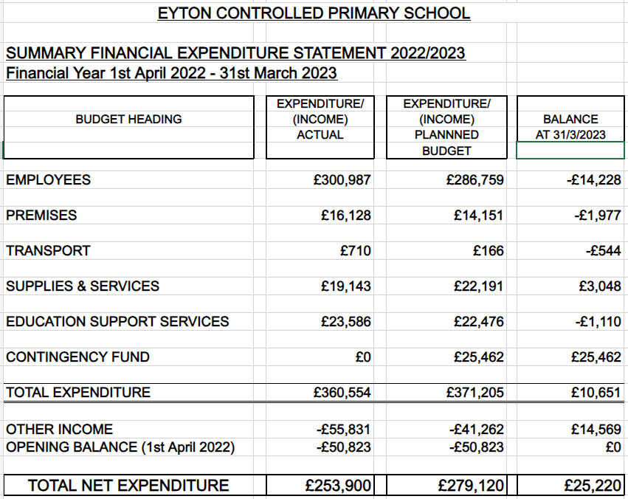
Destination of school leavers:
1 year 6 pupil went to Ysgol Ruabon
1 year 6 pupil went to St Joseph’s's
1 year 6 pupil went to Dinas Bran
8 pupils went to Penley school.

Term dates 2023-2024
Autumn term 1st September-27th October 2023 6th November-22th December 2023
Spring term 8th January-9th February 2024 19th February-22nd March 2024
Summer term 8th April-24th May 2024 3rd June-19th July 2024

