Eyton Church in Wales Voluntary Controlled Primary School

School Prospectus

2023-2024

Tomorrow’s success begins today!

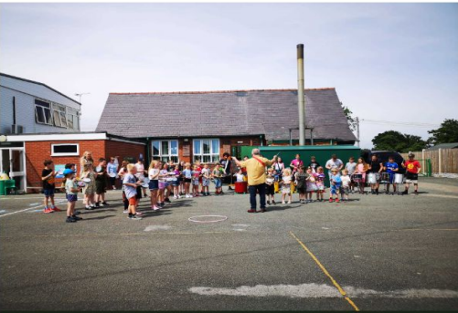

Dear Parents, Carers and Guardians,

Thank you for taking the time to read our school’s prospectus. Inside I hope you will find out a little more about our school and what makes us special. Choosing a school for your child is one of the most important decisions you will make and your child is about to take one of the most important steps of their life, as they begin school for the first time.

Here at Eyton Church in Wales VC School, we think of ourselves as one big family. We provide a happy, caring and stimulating environment, and aim to help your child discover the joy and excitement of learning as we introduce them to new skills and concepts. The high standards of learning are a credit to the hard work of both staff and pupils. We are proud of the atmosphere of friendliness and co-operation which is always evident and frequently commented on by visitors. We provide a broad, balanced and enriched education in Foundation Learning and Key Stage 2.

We foster and nurture a caring, learning environment which is conducive to the personal, social and emotional development of each child within our Christian ethos. Each child at Eyton Church in Wales VC School is equally important and valued. We aim for high levels of progress and standards of behaviour at all times. We value the partnership between home, school and the community because we all want the very best for our children. We will do our best to inspire and challenge your child and we ask for your support in all aspects of school life. We are here to support and work with you, your child and your family, through their primary school journey.

Yours sincerely,
Mrs Louise Whitgreave,
Headteacher.
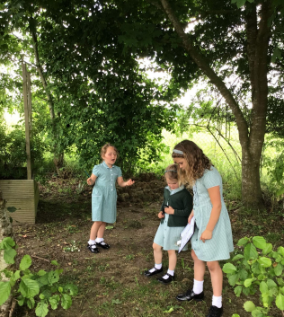

Eyton is a Voluntary Controlled Church in Wales primary school for pupils from the age of 3 – 11. The school is in a rural location and has extensive grounds.

The school was opened in 1856 as a church/school hall. Due to a large extension in the 1960s the school now has three classrooms, a technology room and a nurture room for use by all the pupils. The Welsh curriculum has Digital Competence at its heart as we aim to prepare our pupils for the digital world. As a consequence, we have ensured that the school is resourced with computers, notepads, iPads and access large, interactive screens in each class/department.

At Eyton we also recognise the importance of Outdoor Learning. Pupils across the whole school have regular opportunities to undertake learning in an outside environment, both in our well established forest school area and our wild area. In addition to the forest school area we have, raised vegetable and flower beds which are currently being updated, a large field with adventure trails, an outdoor classroom and a range of play equipment.
We also have Peckingham Palace that houses our school hens. The children learn how to care for the birds and collect the eggs ready to take home for supper!

Our school is an Eco – friendly school (Platinum award). We also hold the Welsh Government National Healthy Schools Quality Award.

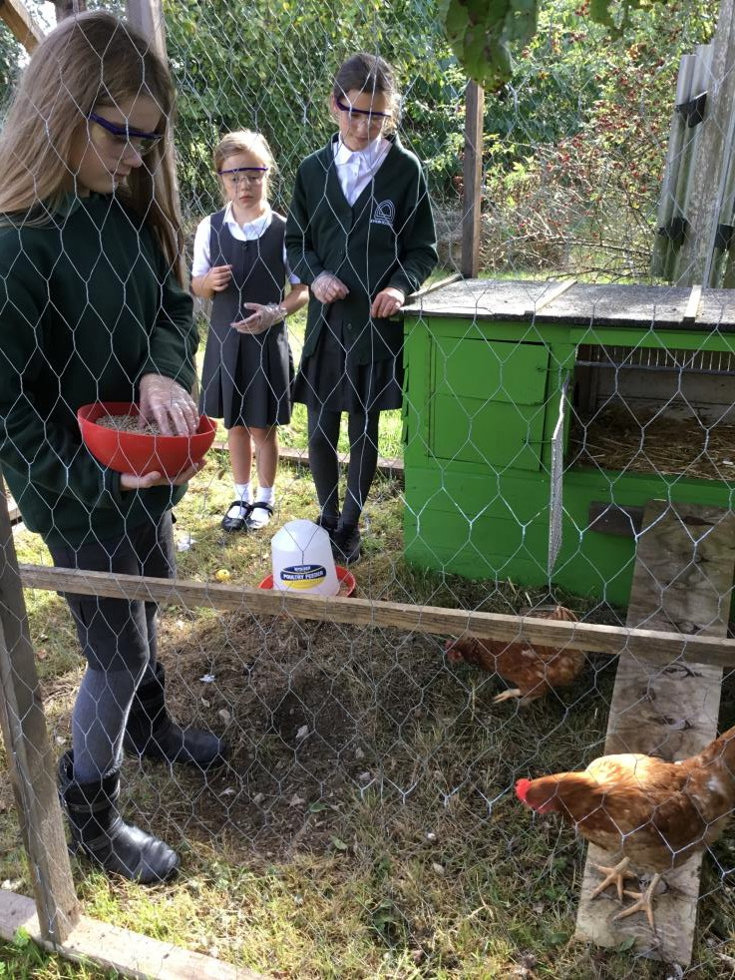

ETHOS

The ethos of the school is based on the fundamental values and beliefs of the teaching of the Christian Faith and recognises that the message of Jesus is the foundation of the educational experience within a Church in Wales School.

As a voluntary controlled school, the focus has always been on developing the whole child not just the parts to be tested and to appreciate and understand the Christian values by which we live.

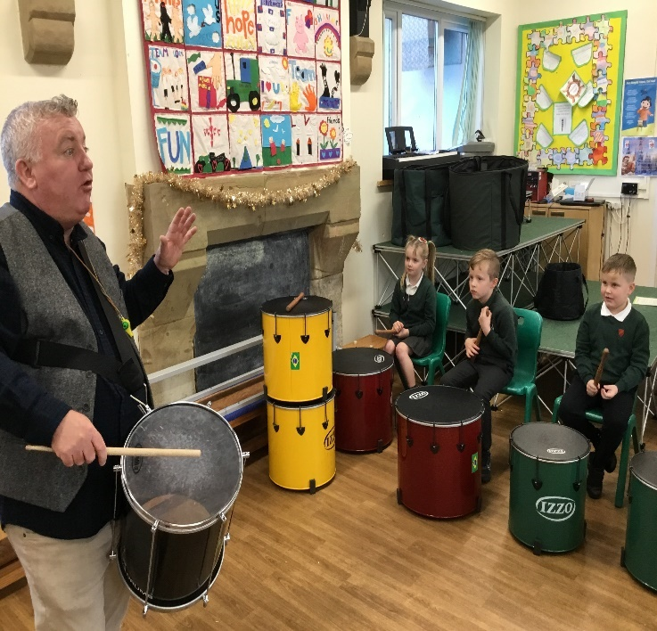

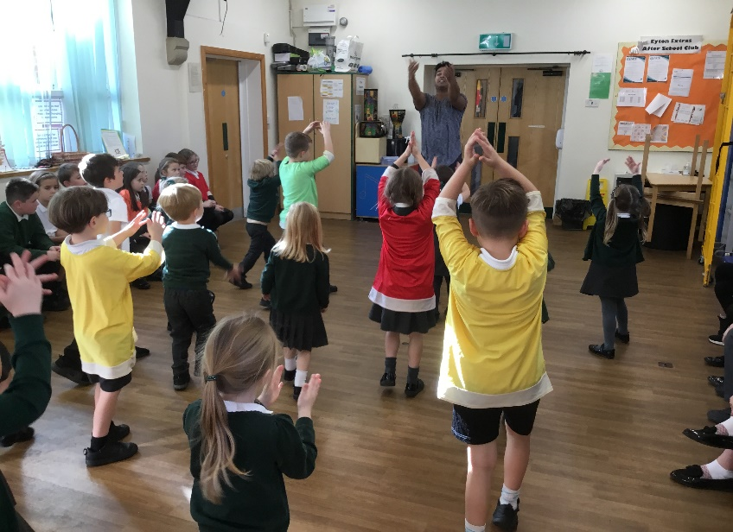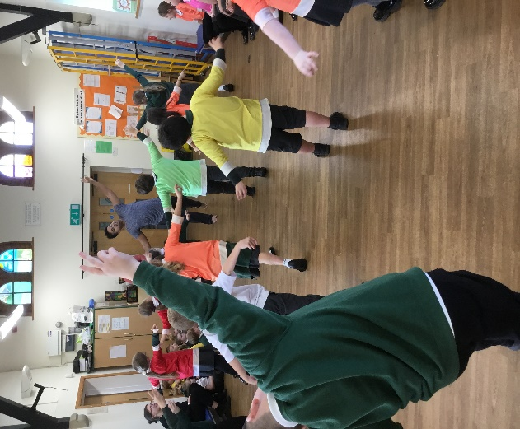

MISSION STATEMENT and VISION
At Eyton CIW VA School together we dream, aspire and achieve through love and faith, as one big family. We foster and create a caring, learning environment for our pupils to be ambitious, confident and independent citizens of Wales and the wider world. We asked our school and wider community what words they would use to describe our school and what makes us special; the words that were chosen and therefore encompass our shared vision are: Respectful, Welcoming, Inclusive, Nurturing, Happy, Fun, Supportive, Kind, Family, Holistic.

“Tomorrow’s success begins today.”

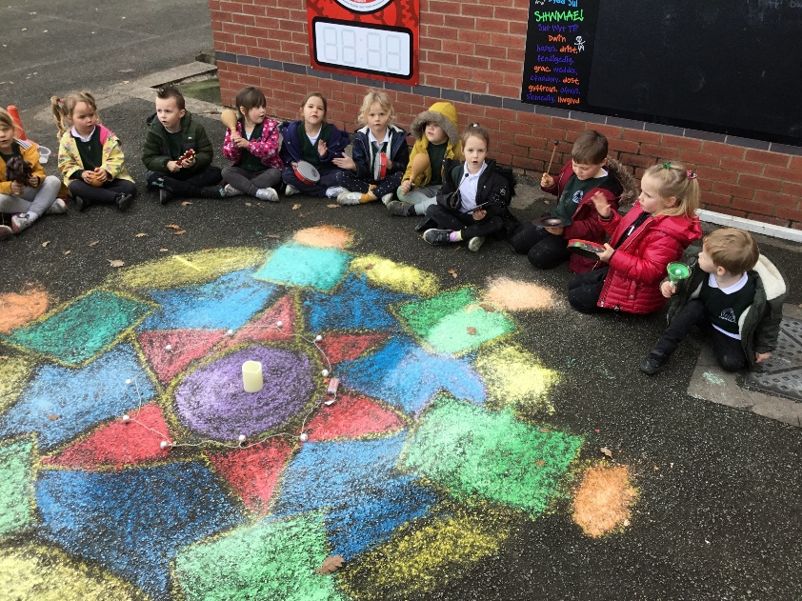

THE SCHOOL DAY

Nursery/Early Entitlement | Foundation Learning (Reception, Year 1, Year 2) | Key Stage Two (Years 3,4,5,6)
12.45pm – 3.15pm | 8.55am – 12.00pm  1.00pm – 3.15pm | 8.55 am – 12.00 pm and 12.55 pm – 3.15 pm
The school gates will be open allowing access to the school at 8:55 am when a member of teaching staff will be there to welcome children and parents. We continue to use the one way system created during Covid to ensure the safety of all entering our school grounds.

To help develop independence and organisational skills, children are encouraged to put any bags and coats in their respective cloakroom area. We realise that this is a busy time of the day and should you need to speak to your child’s teacher please arrange a mutually convenient time.

Staff List 2023-2024

Headteacher Mrs Louise Whitgreave

Y5/6 Teacher Mrs Hayley Hughes/Mrs Whitgreave

Y3/4 teacher Mr Martyn Pugh/Mrs Whitgreave

Foundation Learning Teacher Mrs Kathryn Collins/Mrs Whitgreave

ALNCo Mrs Louise Whitgreave

KS2/ALN Teaching Assistant Mrs Jan Davies

Foundation Learning Teaching Assistants Miss Maddie Stella/Mrs Claire Jones

School Secretary Mrs Viv Moore
School Cook Ms Debbie Lynch
Lunchtime Supervisors Mrs Viv Moore/Mrs Helen Durnell
School Caretaker/Cleaner Mr Mark Jones
Breakfast Club Mrs Viv Moore, Mr Mark Jones, Mrs Liz
Lambert, Mrs Sara Williscroft

CURRICULUM
Our school has a committed staff who take pride in a strong teamwork approach to all aspects of our work. All members of staff are involved in school management and curriculum planning. There is no substitute for the basis of a sound education and we aim to achieve this by well-planned, imaginative and committed teaching. A great deal of care is taken in planning the curriculum and the organisation of the school to meet the individual needs of each child. Class teachers meet with parents each term and provide details of curriculum and their child’s progress.

We provide our pupils with a curriculum which seeks to educate ‘the whole child’ as well as in academic and creative ways. We strive to make our curriculum appropriate to pupils’ needs with a variety of teaching styles that develop positive attitudes to learning, the understanding of concepts and the acquisition of knowledge and skills to create lifelong learners.

The content of our curriculum is broad, balanced, relevant, interesting and purpose driven. We are currently working hard to ensure we are meeting the needs of the new curriculum and have produced an additional document entitled Curriculum Rationale which sets out our vision and purpose. A copy of this document can be obtained from the school office or via our school website. For us at Eyton the introduction of new curriculum requirements has been a smooth transition as we already place great importance on experiential and thematic learning which underpins the new curriculum. We aim to develop the skills of independence and curiosity. Ensuring all pupils have a positive disposition to learning, with their wellbeing - both emotional and physical – is at the very heart of everything we do.

The new curriculum is based on four key purposes:
- ambitious, capable learners, ready to learn throughout their lives
- enterprising, creative contributors, ready to play a full part in life and work
- ethical, informed citizens of Wales and the world
- healthy, confident individuals, ready to lead fulfilling lives as valued members of society.

The new curriculum organises learning around six areas of learning and experience which are:
- Expressive Arts
- Health and Well-being
- Humanities
- Languages, Literacy and Communication
- Mathematics and Numeracy
- Science and Technology
We provide a rich and experiential curriculum and aim to harness the outdoors and our local community wherever possible. Forest school is timetabled regularly for all pupils across school and is an integral part of our curriculum offer. A variety of clubs are offered such as football, athletics, netball, cricket, choir, art and ICT.

We encourage high standards of behaviour by all pupils. We use the Pivotal principles of positive behaviour management, using the 3 key phases of ‘Ready, Respectful, Safe’ as a common language throughout the school and encourage ‘Wise Walking’ when moving around our school.

NURSERY and EARLY ENTITLEMENT PROVISION
Pupils are admitted to the Nursery, which is part of our Foundation Learning class in the academic year in which they are four – i.e. any child who is three by the 31st August can be admitted in September. Nursery is a statutory provision; however, it is not compulsory education. Admission to Nursery does not guarantee admission to Reception; if a child has a place in our Nursery the appropriate application form for admission into Reception must be submitted within the prescribed timescale of the annual admissions round.

Pupils are admitted to Reception in the academic year in which they are five i.e. any child who attains the age of four by 31st August can be admitted in September.

WELSH LANGUAGE
At Eyton we are very proud of our country’s language and its rich cultural heritage and traditions. We provide numerous bilingual opportunities for pupils to experience and use the Welsh Language. The pupil led ‘Criw Cymraeg’ promote pupils understanding of the Welsh culture and use of language and it is an integral part of daily routines across the whole school.
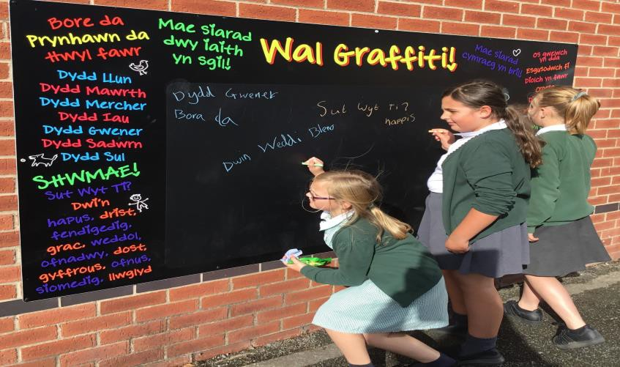

ATTENDANCE AND PUNCTUALITY
Regular and punctual attendance is essential if pupils are to make good progress. If your child is absent you must inform school during the first morning of absence. If we have not heard from you, you will be contacted for an explanation of the absence.

Green | 100% | Not missing any lessons.
 | 99% | Missing about 10 lessons.
 | 98% | Missing about 20 lessons.
 | 97% | Missing about 30 lessons.
Amber | 96% | Missing about 8 days of school. It will be difficult to catch up on the lost learning from about 40 lessons.
 | 95% | Missing about 2 weeks of school.
 | 93% | Missing 14 days of school. This is almost three weeks which is a significant amount of education  to lose.
Red | 92% and below | Missing more than 3 weeks of education. A serious loss of learning which is likely to have a detrimental effect on achievement and life chances.

The school actively discourages late arrival. All parents are responsible for their child’s travel arrangements to school and to ensure their child arrives at school on time. All pupils arriving after 9.00am must enter through the main reception door and be signed in at the school office by their parent/carer. Pupils are marked late after 9.20 am and a reason will be requested.

Advance notice of family holidays must be submitted in writing on the appropriate holiday form, available on request from the school office. Authorisation of family holidays is at the discretion of the Headteacher up to a maximum of 10 days in an academic year.

Disruption in school attendance can effect a child’s educational development and performance. During May and June, children undergo a variety of assessments at school which also includes the National Literacy and Numeracy tests. We respectfully request that holidays are not taken at this time. Absences and lateness are monitored very carefully by the Headteacher and our Education Social Worker.

*Please note that as of September 2014 the Local Authority has been given powers to issue Fixed Penalty Notices of £60 for unauthorised absences.

LINKS WITH THE CHURCH
The ethos of the school rests on Christian values and the children are taught within a Christian ethos. Our vicar, Reverend Sue Huyton visits our school services are held at in Church during the year. Services include: Harvest, Easter, and an end of year service, as well as regular class led services which focus on our Christian values.
We have had our work about The Parable of the Lost Sheep displayed at the Diocesan head office in St Asaph.

COMMUNITY
Developing and maintaining community links is an important part of the ethos of our school; we see the school as a vital part of the whole community. We have been able to use local facilities for activities like pond dipping. We worked with a local artist to paint one of the sheep for the Wrexham Sheep Trail, which now resides at the local farm shop. The children joined in with a local martial arts teacher for a series of workshops from the local club. We often use the wealth of resources on our doorstep to bring Cynefin and our learning to life.

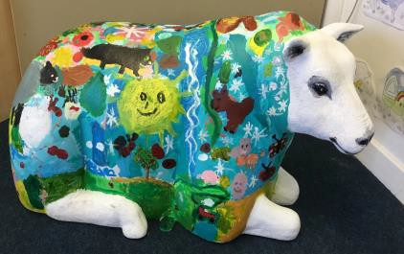
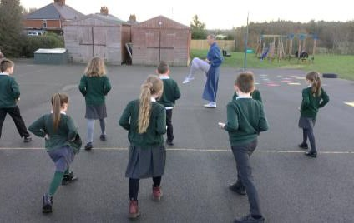
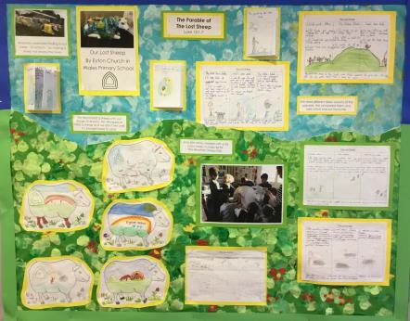

EDUCATIONAL VISITS
Parents will be informed well in advance of any educational visits. Children are expected to wear school uniform on any day outings unless directed otherwise. Each visit complies with the Governors’ charging and remissions policy and although no charge is made for activities/visits, which are held mainly in school time, the school may ask parents to make a voluntary contribution to help meet the costs incurred for transportation, entrance fees, visitor’s fees etc. Regular locations include:
  - St Asaph Cathedral
  - Pentrellyncymer residential
  - Nant Bwlch yr Haearn residential
  - Bryntysilio residential
  - Techniquest
  - National Trust properties
  - Wrexham town centre/St Giles Cathedral (7 wonders of Wales)
  - Llangollen International Eisteddfod
  - Dangerpoint
  - Rhyl Sealife Centre and beach
  - Local Garden Centre
  - Chester Zoo

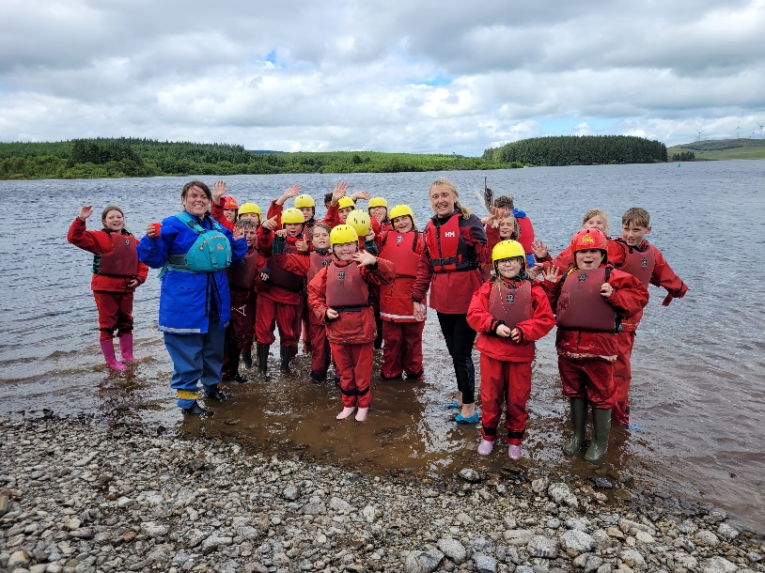

SCHOOL UNIFORM
Please ensure all items of clothing are clearly labelled with your child’s name.
Our school has a uniform and parents are requested to provide their child with the appropriate clothing.

Dark green sweatshirt/cardigan, which can be purchased with the school logo, green or white polo top or shirt, grey trousers/skirts, and in the summer, green gingham dresses and grey shorts.

Grey, black or white socks or tights and black shoes. Trainers may not be worn except for PE lessons. Uniform in our school colours is available from several retailers including many supermarkets. School uniform with a logo is available from, website address below:
https://www.monkhouse.com/school/eyton-primary-school-urn-400448

P.E. kit - Pupils are required to come to school in their P.E. kit on their timetabled day.
Plain white T shirts or a plain sweatshirt are to be worn. These are to be accompanied by black shorts/leggings/jogging trousers and suitable footwear.

All pupils regularly take part in outdoor activities. It is imperative the children come to school appropriately dressed for these sessions as the children are undertaking activities outdoors in all weathers. Class teachers will communicate what is needed during these timetabled sessions. Forest School kit consists of waterproof coat and trousers with warm underlayers e.g. jumpers, fleeces, extra socks, wellington boots or snow boots, hats, gloves and a scarf in winter months. In warmer weather children must wear long sleeved tops and long trousers, sun hats or a cap, sunscreen and sturdy outdoor footwear e.g. trainers or boots.

For Health and Safety reasons, no jewelry is to be worn to school other than a watch and plain pierced ear studs. No make-up is to be worn. If specific jewelry or items of clothing are worn due to religious beliefs, then parents are asked to discuss such arrangements directly with the Headteacher so issues, such as those dealing with health and safety, can be addressed and mutually agreed.

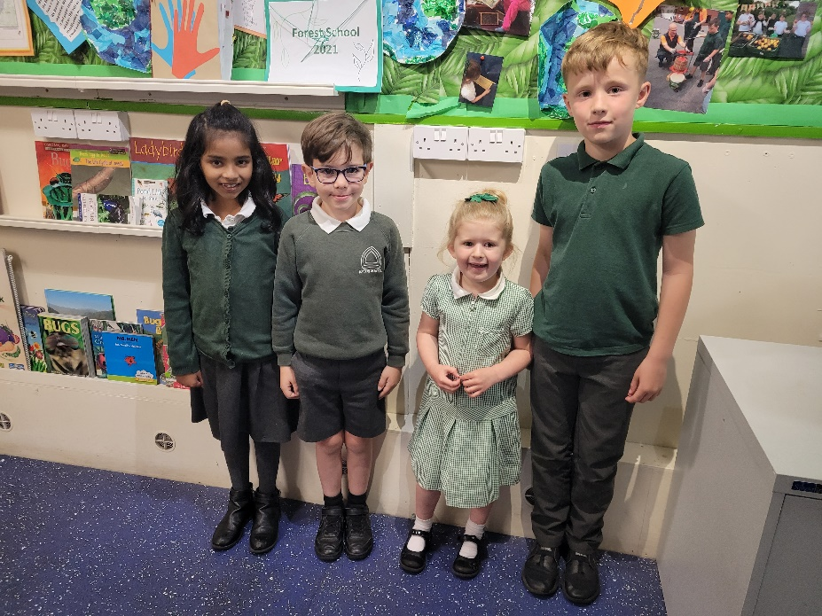

SCHOOL MEALS AND SNACKS
At Eyton we always promote healthy eating with all pupils and adhere to the Healthy Eating in Schools (Wales) Regulations. Eating a healthy balanced meal is vital for a child’s health, growth and development. Good nutrition also boosts concentration levels, perfect for helping improve their performance at school. Milk is provided free of charge for all Foundation Learning pupils.
All pupils at Eyton are now eligible for Free School Meals. There is a meat and vegetarian choice every day, plus jacket potatoes and freshly made sandwiches with the choice of a variety of fillings. Meals should be ordered in advance, still through the Parent Pay app, before 8am each day.

If children are bringing a packed lunch to school, please ensure these are healthy and in keeping with our whole school approach. Healthy eating is always encouraged at Eyton and any snacks provided for the children should be healthy in nature. Our Student and Eco Council are currently developing a strategy to combat waste, litter and to encourage a healthy choice.

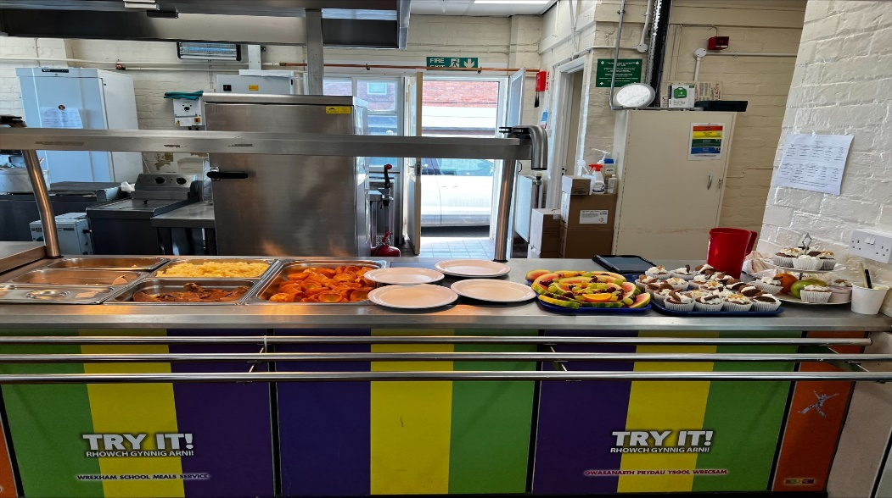

PARENTS, TEACHERS ASSOCIATION (PTA)
Eyton Church in Wales V.C. Primary is a school that places great importance on fostering strong links with the community. Many events take place through the year to which parents and friends are invited, and we hope you will enjoy joining in. We have a newly formed friendly and active PTA which is open to all. The support of this group is invaluable to the school and their hard work benefits all of our pupils. Any offer of help, either in an official capacity on the Committee, or on a purely voluntary basis at individual functions is welcomed.

EQUAL OPPORTUNITIES
The philosophy at Eyton School is that of openness, where everyone is welcome and the children are encouraged to greet visitors with friendliness and respect. Within an environment that provides equal access to learning facilities, resources and opportunities, the school aims to give each pupil the opportunity to succeed and reach the highest possible level of personal achievement. Expectation is consistently high, regardless of a pupil’s age, gender, ability, ethnicity or social background. The school is bound by legal requirements and is guided by the Wrexham County Borough Council and the Church in Wales. It is committed to providing an environment that allows full access to all areas of learning. The school has adopted the LA’s Equal Opportunities policy and always endeavours to uphold it.

ADDITIONAL EDUCATIONAL NEEDS

Our school, along with all schools in Wales are currently moving through some significant changes to expectations, experiences and outcomes for children with additional learning needs (ALN). To do so, Welsh Government have developed the additional learning needs (ALN) transformation programme, to create a unified system for supporting learners with ALN.
The transformed system will:
- ensure that all learners with ALN are supported to overcome barriers to learning and
achieve their full potential
- improve the planning and delivery of support for learners with ALN, placing learners’
needs, views, wishes and feelings at the heart of the process
- focus on the importance of identifying needs early and putting in place timely and effective interventions which are monitored and adapted to ensure they deliver the desired outcomes.

Partnership with Parents/Carers

The child is at the centre of everything we do and we will work with families to achieve the best outcomes for their child.
Our school is committed to establishing and maintaining good working relationships with the families of all our pupils and recognises the importance of a partnership between home and school. Parents are kept informed of children’s progress and are encouraged to play an active part in their children’s learning and to support targets set.

Parents with concerns about their child should discuss these first with the class teacher who will inform the Additional Learning Needs Coordinator if necessary. Parents are fully involved in the review process. Written information is in accessible formats and sufficient notice is given for meetings to enable parents/carers time to prepare.

Pupil Participation

The views of all pupils are valued. A person-centred approach is adopted throughout our school, placing the child/ young person at the heart of everything we do and celebrating what they can do. Pupils with ALN are supported to be involved in decision making and to be able to express any concerns.

HOMEWORK
The school has a homework policy which has been agreed by pupils, parents, staff and governors. Class teachers will inform parents of the appropriate homework. Homework may come in many different guises, including projects, research, art work, spellings, maths, online activities, reading practice etc. When homework is given, parents are asked to give support and encouragement. Parents may wish to give guidance and work alongside their child but are requested to allow the child to do his/her own work. Should children struggle with any aspect of homework then please inform the class teacher at the earliest opportunity.

RELATIONSHIP AND SEXUALITY EDUCATION

At Eyton it is our aim to ensure that our children grow up as informed and responsible adults. We aim to equip our children with the skills and information to be able to differentiate between accurate and inaccurate information, discuss a range of moral and social issues and perspectives on sex and sexuality, including different cultural attitudes and sensitive issues.

The overall objective of RSE (Relationship and Sexuality Education) is to help and support our children through their physical, emotional and moral development. This will enable our pupils to learn to respect themselves and others and move with confidence from childhood through to adolescence and then to adulthood.

Our RSE programme is not taught in isolation. It is firmly rooted in our PSHE (Personal, Social and Health Education) framework with Jigsaw and science schemes of work; an example being where certain biological aspects are also delivered through science lessons as part of ‘Life and Living Processes’ topic.

Relationship and Sexuality Education takes place within mixed gender classes with each class teacher being responsible for the delivery of RSE within their own classroom and each follow the Jigsaw PSHE scheme of work.

Parents are reminded that they cannot withdraw their children from all or part of the sex education provided. Parents may view materials used to provide RSE which are available on request. A copy of our school RSE policy is available for parental inspection from the Headteacher.

SCHOOL SECURITY
Access to and from the school building is carefully monitored and the school site is secure at all times of the day. CCTV cameras are fitted for security reasons around the outside of the school building. Parents and visitors enter the school via the main door by using an intercom system. For security reasons all visitors are asked to report to the school secretary to sign in on arrival and out and the end of their visit. All staff and visitors wear identification badges.

SAFETY
Eyton Church in Wales V.C. Primary School has the highest regard for the quality of education and personal safety of all the children in our care. Initiatives such as Bikeability cycle training for Y6, workshops provided by the NSPCC, regular visits from our Police Education Team and others visitors support and add to the education we provide our pupils. Pupils only leave the school with the knowledge of and under the guidance of a member of staff and for agreed purposes e.g. walking to Church. Pupils must be signed out if they are collected in during the school day. At home time pupils are released one by one to a parent/carer or by a nominated representative.

Parents may wish pupils in the KS2 to make their own way home. If this is the case, please make sure your child and the school is fully aware of your arrangements by way of your written consent.

To assist with the children’s safety parents are requested to:
  - Use the pedestrian gates to enter the grounds and not the car park entrance. The car park is only for use by school staff.
  - Not to park on areas outside the school gates where no parking is indicated.
  - Be especially careful when opening car doors.
  - Drive slowly along the roads in the vicinity of the school.
  - Follow the one-way pedestrian route on their way in and out of school.
  - Please do not block the driveway immediately next to the school.

We would like ALL parents to reinforce their children’s awareness of safety and help
them become responsible road users.

SAFEGUARDING and CHILD PROTECTION
Welsh Assembly Government and local authority guidance makes it clear that schools have an integral role to play in the protection of children against abuse. Eyton V.C. Primary School School, therefore, has a duty to refer any concerns about the well-being of pupils to the Social Service Department. The person responsible for Child-Protection and Safeguarding is Mrs Whitgreave (Headteacher) or Mr Pugh, (Class Teacher).

HEALTH MATTERS

If your child becomes ill during the school day, parents or other nominated family members are telephoned. A similar process is adopted in the case of accidents and therefore the school needs to know up to date telephone numbers where parents can be contacted.

Accidents at school are treated initially by staff members who have completed an Emergency First Aid course and recorded in an ‘Accident Book’. In the event of a more serious accident an ambulance will be called to take the pupil to hospital and a member of the school staff will accompany the pupil in place of a parent. In both instances parents are contacted as soon as possible.

In most cases medicine cannot be administered in school by staff. Only prescription medicines, clearly labelled by a Dr or Pharmacist’s label, that need to be taken during the day, can be administered. Parents need to fill out a medicine form, available from the school office.

A useful chart, published by the Department of Public Health, which lists the incubation and exclusion periods for the more common infectious diseases is helpful when regarding a pupil’s absence from school with one of these diseases. Parents are requested to adhere to the guidelines. Please contact the school for further information regarding these guidelines: https://www.publichealth.hscni.net/sites/default/files/Guidance_on_infection_control_in schools_poster.pdf

EFFECTIVE COMMUNICATION
Confidence in a school comes from knowing and understanding what is happening within it and therefore we are always open to suggestions for improving communication with parents.

The staff and governors of Eyton Church in Wales V.C. Primary School are committed to ensuring that your child has valuable learning experiences. It is essential that school provides a caring environment for children to achieve their full potential. Parent and teachers working together can establish mutual understanding, trust and shared responsibility. The school regularly asks parents and pupils and stakeholders their opinion on a range of matters and are always keen to listen to suggestions. The school uses SeeSaw to keep in touch with parents and is very proud of the strong communication that exists.

Parent’s evenings are held to discuss your child’s progress and parents/grandparents are invited into regular Sharing Time throughout the year. However, parents are encouraged to contact the school and discuss any issues they may have concerning their progress at any time throughout the academic year. Class teachers are usually available to speak to parents at the end of the school day.

If you are experiencing any family problems or difficulties that may affect your child’s well-being, please let us know as this knowledge will help us in looking after your children.

It is important to make sure you have signed up to SeeSaw and the text messaging service for more urgent communications. The school also has website:

https://eytonprimary.co.uk/

Each week you will receive a newsletter via the website, (if you require a paper copy please ask your child’s teacher). The newsletter will include information about the theme of the term, as well as diary dates, P.E and a picollage of the week’s activities.

PARENT PARTNERSHIP
At Eyton V.C. Primary School, we value you as parents and the special partnership we will have in educating your child together. We place great importance and value on your child’s well- being and work hard to ensure that our school has a happy and stimulating environment and one that you feel that you are able to approach any member of staff with any questions or queries you may have. The ethos of our school places high value on respecting and caring for others and building an environment in which all children feel valued and their voices are heard.
We look forward to meeting you to discuss any concerns that you may have. We ask you to make an appointment to come into meet us and discuss any issues in a calm and reasonable manner.

HOME SCHOOL AGREEMENT
The school has a home school agreement between pupils, teachers and parents regarding each child’s education. This is part of pack that you will receive when your child joins us at Eyton V.C. Primary School.

WRITTEN REPORTS
At the end of the summer term you will be provided with a written report on your child’s progress, a copy of which will be kept in school. If you would like to discuss the report, you will be invited to make a mutually convenient appointment with your child’s class teacher.

BREAKFAST CLUB AND EYTON EXTRAS AFTER SCHOOL CLUB
A breakfast club is run each day from the school hall. The club opens at 8.00 a.m. until 8.55 a.m.
In the afternoon, Eyton Extras runs from from 3:15 – 5:10p.m.
Parents wishing their children to attend need to complete a registration form in the office for breakfast club and with Mrs Jones at the school for Eyton Extras.

COMPLAINTS

Most problems can be resolved at this early stage with your child’s class teacher but should a parent feel the matter has not been resolved then we would ask that you speak the headteacher. The Headteacher and Chair of Governors are also available to discuss any concerns that may arise. The school has a Complaints Policy, which is available and lists procedures and suggested timescales to follow.

ADMISSIONS

As our school is a Church in Wales Voluntary Controlled School, the local authority, Wrexham County Borough Council controls our admissions as the admissions authority for our school.

Application forms are available through Wrexham Local Authority website and are completed online. https://www.wrexham.gov.uk/english/education/admissions_index.htm

If your child wishes to transfer from another school during the school year, your child is more than welcome to have some taster sessions and a chance to meet their peers and get to know our school.

Admittance into nursery will entail a number of ‘taster sessions’ and an informal class session where parents are encouraged to stay and get to know each other too.

TRANSFER TO SECONDARY SCHOOL
The feeder school for Eyton is the Maelor School, Penley. The Headteacher meets regularly with the Headteacher of Penley and other feeder school Heads, in order to plan events which will help to prepare our Year 6 pupils for life in secondary school. Year 6 pupils make visits to The Maelor School and other local secondary schools – both State and Private - and their staff visit us at Eyton. The school also holds an open day/evening to enable parents to view facilities and meet staff.

Mrs Karen Evans

Children & Young People Services W.C.B.C.
16 Lord Street Wrexham LL11 1LG
Mrs Maxine Jones
Governor Support Assistant
Lambpit Street
Wrexham LL11 1AR

Mrs Sandra Jones

Eyton V.C. Primary School
Bangor Road,
Eyton,
LL13 0YD

Director of Education
Clerk to the Governors
Chair of Governors

Thank you for taking the time to read our prospectus. As you can see we are very proud of our school. Should you like to find out more then please contact us on 01978 923392 or mailbox@eyton-pri.wrexham.sch.uk

