Snow Day 10th March expressive Arts KS2

What matters for a snow day: Creating combines skills and knowledge, drawing on the senses, inspiration and imagination.

Progression Step 2: I can perform, produce, design, exhibit and share my creative work in a variety of ways for different audiences, inspired by a range of stimuli and experiences.

Progression Step 3: I can perform, produce, design, exhibit and share my creative work in formal and non-formal contexts, considering the impact of my creative work on the audience.

You won’t need any special art materials for this lesson.

Resources:
A kitchen tray or a baking tray,
Mark-making materials like a dinner fork, a potato masher, a tea strainer, a wooden skewer,

A rolling pin or something to flatten the snow with,

A tray of snow.

A piece of paper and a pencil.

A camera

Have a look at the BBC news report about snow artist Simon Beck

1.BBC: Snowshoe artist Simon Beck's vast snow art in Colorado
- Published17 January 2020
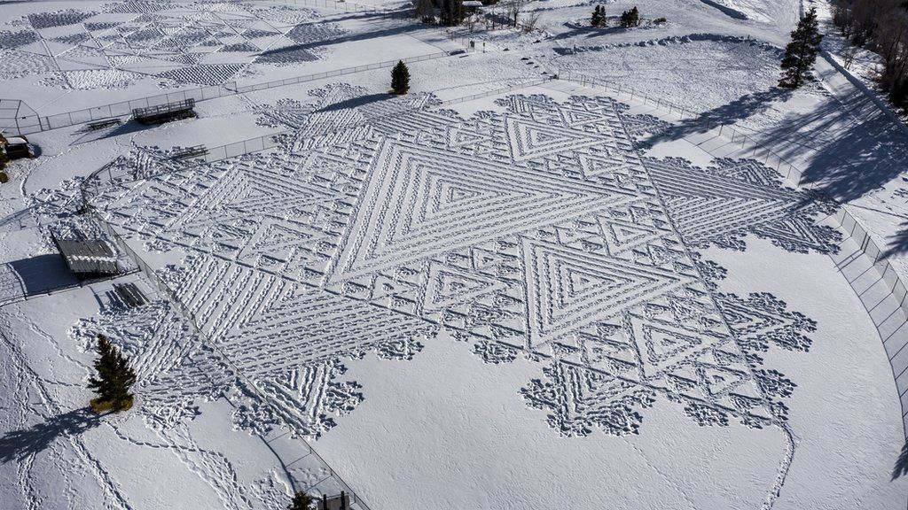IMAGE SOURCE,TOWN OF SILVERTHORNE
The snowshoe artist creates detailed geometric designs by walking for miles in snowshoes
An artist from Somerset has walked more than 50 miles (80km) in circles wearing snowshoes to create vast snow drawings in Colorado.
Simon Beck, from Taunton, battled high winds and "very light" snow to create eight detailed designs in the freshly laid white stuff around Silverthorne.
The designs, which are best appreciated from above, are inspired by snowflakes, crop circles and mathematical fractals.
Mr Beck has set a personal record for the most designs created in one place.

His designs, which are best appreciated from above, are inspired by snowflakes, crop circles and mathematical fractals
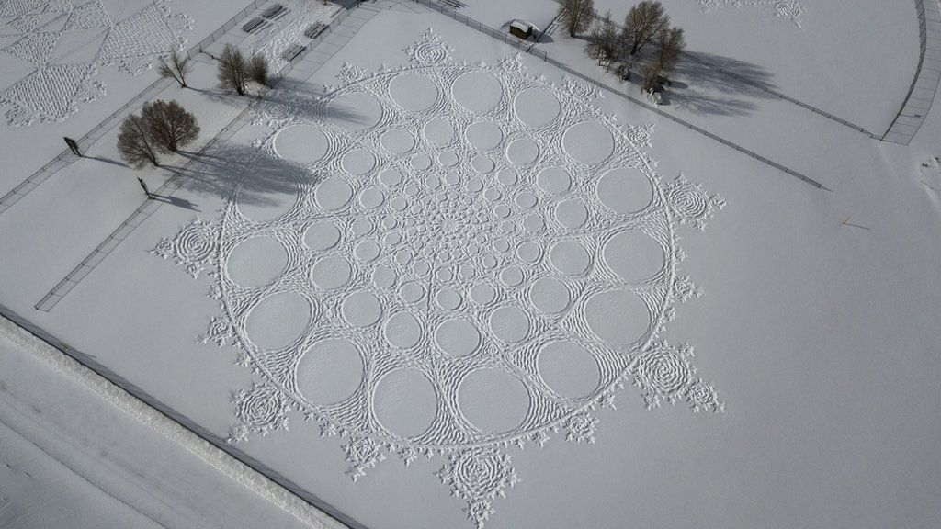IMAGE SOURCE,TOWN OF SILVERTHORNE
He has created eight vast snow drawings in one week in Colorado
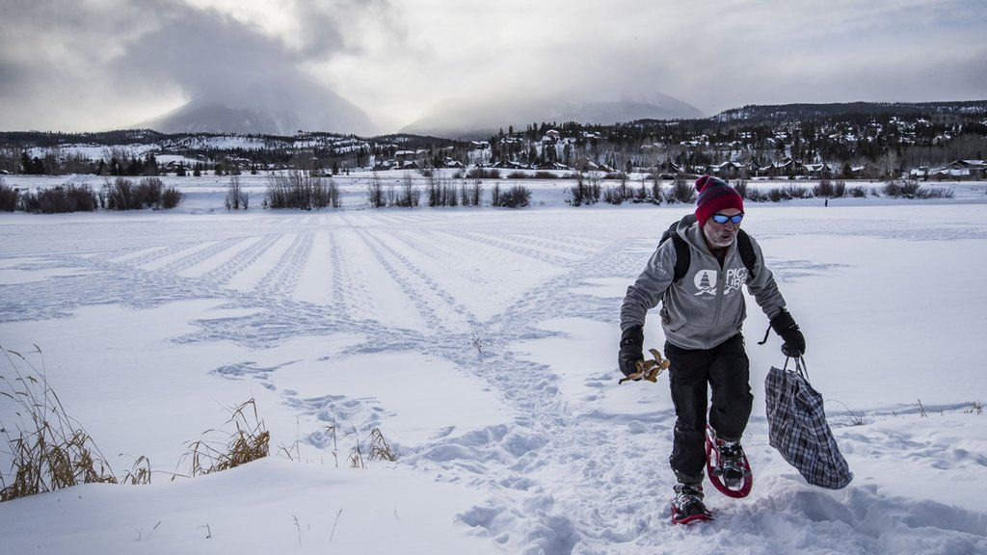IMAGE SOURCE,TOWN OF SILVERTHORNE
An expert in orienteering, Simon Beck uses a compass and set of sketches to measure how many steps will be needed for each part of the drawing before he sets out
The 61-year-old flew to Colorado at the beginning of January to pace out 10 giant murals, weather permitting, over the course of two weeks.
Best known for making huge geometric snow designs in the Alps with his feet, he said the snow in Colorado was different.
"It is very light due to the dry atmosphere in the interior of the continent, and it just blows about," he said.
"It doesn't seem to stick down into a snowpack as it does in the Alps."
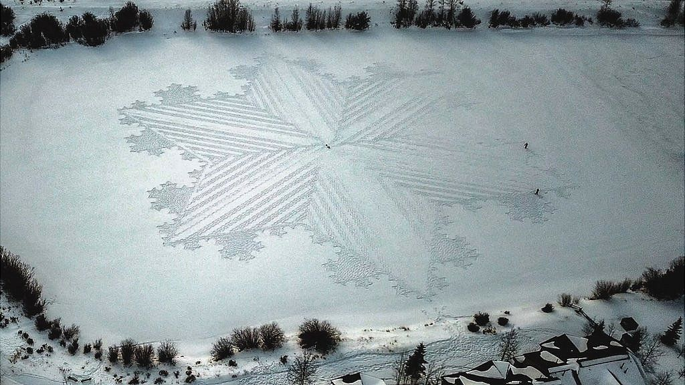IMAGE SOURCE,TOWN OF SILVERTHORNE
Image caption,
The images sometimes take more than 11 hours to make, and the artist can walk miles while completing a single piece
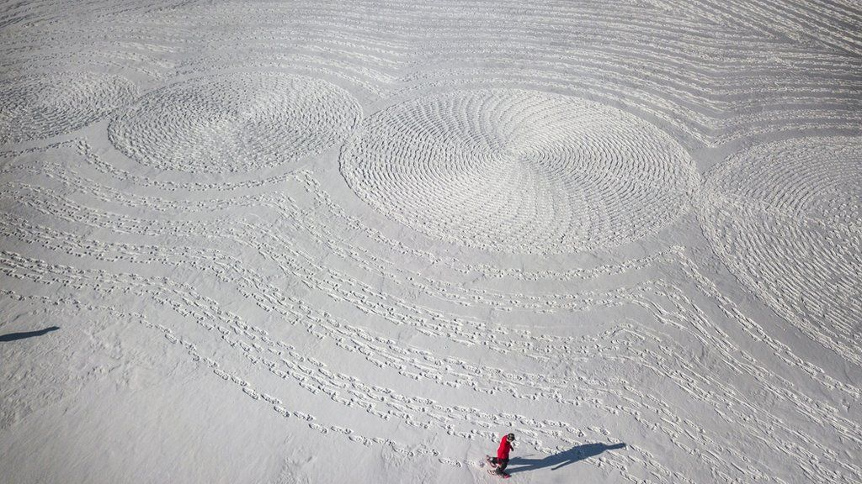IMAGE SOURCE,TOWN OF SILVERTHORNE

His art lasts only as long as the conditions hold. If it snows, his work is gone
The artist also had to battle high winds which "steadily removed" a lot of his work.
"There were two drawings that took a day and a half to make and the first was blown away," he said.
"And all the drawings were damaged to an extent by the wind. A quarter of my time was spent reinstating work I had done earlier."
The orienteering expert managed to stamp out eight massive snow murals across parks, the banks of a lake and baseball fields.
"I had seven volunteers at most helping me," he said.
"Shading is something anyone can do with 10 minutes practice but there is the danger they could make a mistake, so one has to keep an eye on them."

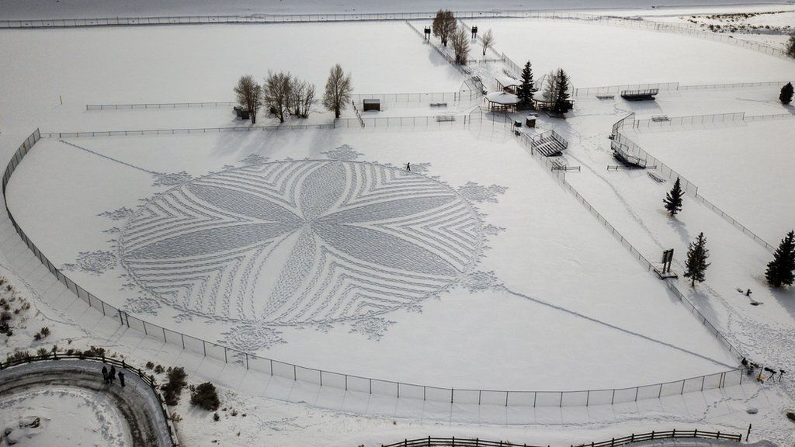IMAGE SOURCE,TOWN OF SILVERTHORNE
Image caption,
He says he does not mind the ephemeral nature of the drawings providing he can take a photograph of them first.

- Have a go in some snow, mark-making with your equipment, try them out to see what they do.
- Design your snow pattern on a piece of paper; sketch it with a pencil. Remember to think about the outline shape of your tray.
- Get creative and make your pattern on your tray. If you can, take a photograph of it.
- On the back of your design, write what you really like about your pattern and what you’d do to make it even better next time.

I hope you’re having a lovely day and I’ll see you next week.
Mrs Whitgreave

