Note for Parents
The activities below are practical activities for you and your child to enjoy. How and when you do them is up to you and your child. Please do not worry about getting them all completed or if they take longer than a day, that is fine. Choose a time that suits you and your child, this may change from day to day.

To access a ‘Task of the day’ you just double click the word document icon. This will bring up another word document that has all the instructions you need to complete the task. Most of the things you will need for the task will be found in your home or nearby. If an app is mentioned, there will be a link below it with a ‘How to’ video to help you out.

Please feel free to contact me on jessons@hwbmail.net If you want to share any photos work that your child has done please do. I am unable to open videos.

These activities are for Years 1&2. If your child chooses to do something more challenging from the list, that’s great, but please do not feel pressured to do them all. The most important thing is the health and well-being of your family. These activities should be fun and give you valuable time together to talk, share and create things.

Model
All main activities for the week, choose 1 each day; Choosing Board for the week, choose one or two activities per day; Physical/well-being activities for the week – choose two activities daily; 1 daily reading activity.

- Daily Activity

5 daily activities for the week. Choose one every day.

Double click on the icon below for more information about the activity:

Create your own shop | Scavenger hunt and poetry writing | Recycling in your home | Book Favourites | Presenting a Vlog
- Choosing Board
Choose one or two of the activities below.
Click here for more information

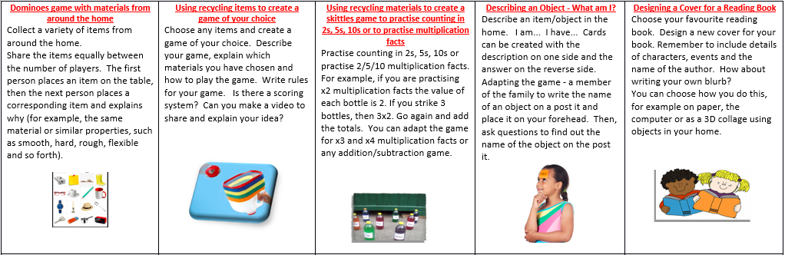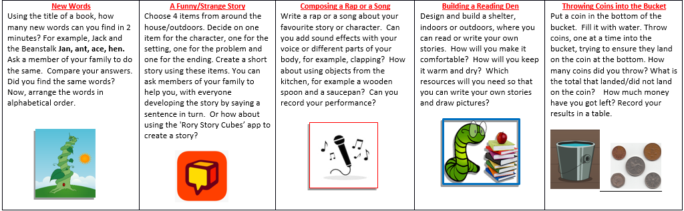

- Physical/Well-being Activities
Please select two of the activities below.
Click here for more information:

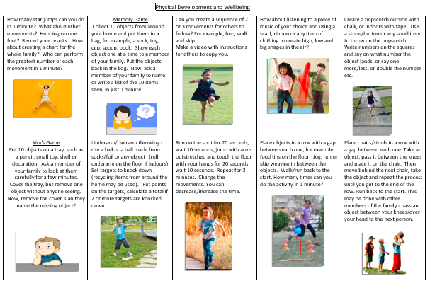
- Listen or read a story.
Share your favourite book with a family member; this can be a bedtime story.

