Mrs Bliss from Warburtons Bakery worked with Dosbarth Buddug this afternoon.
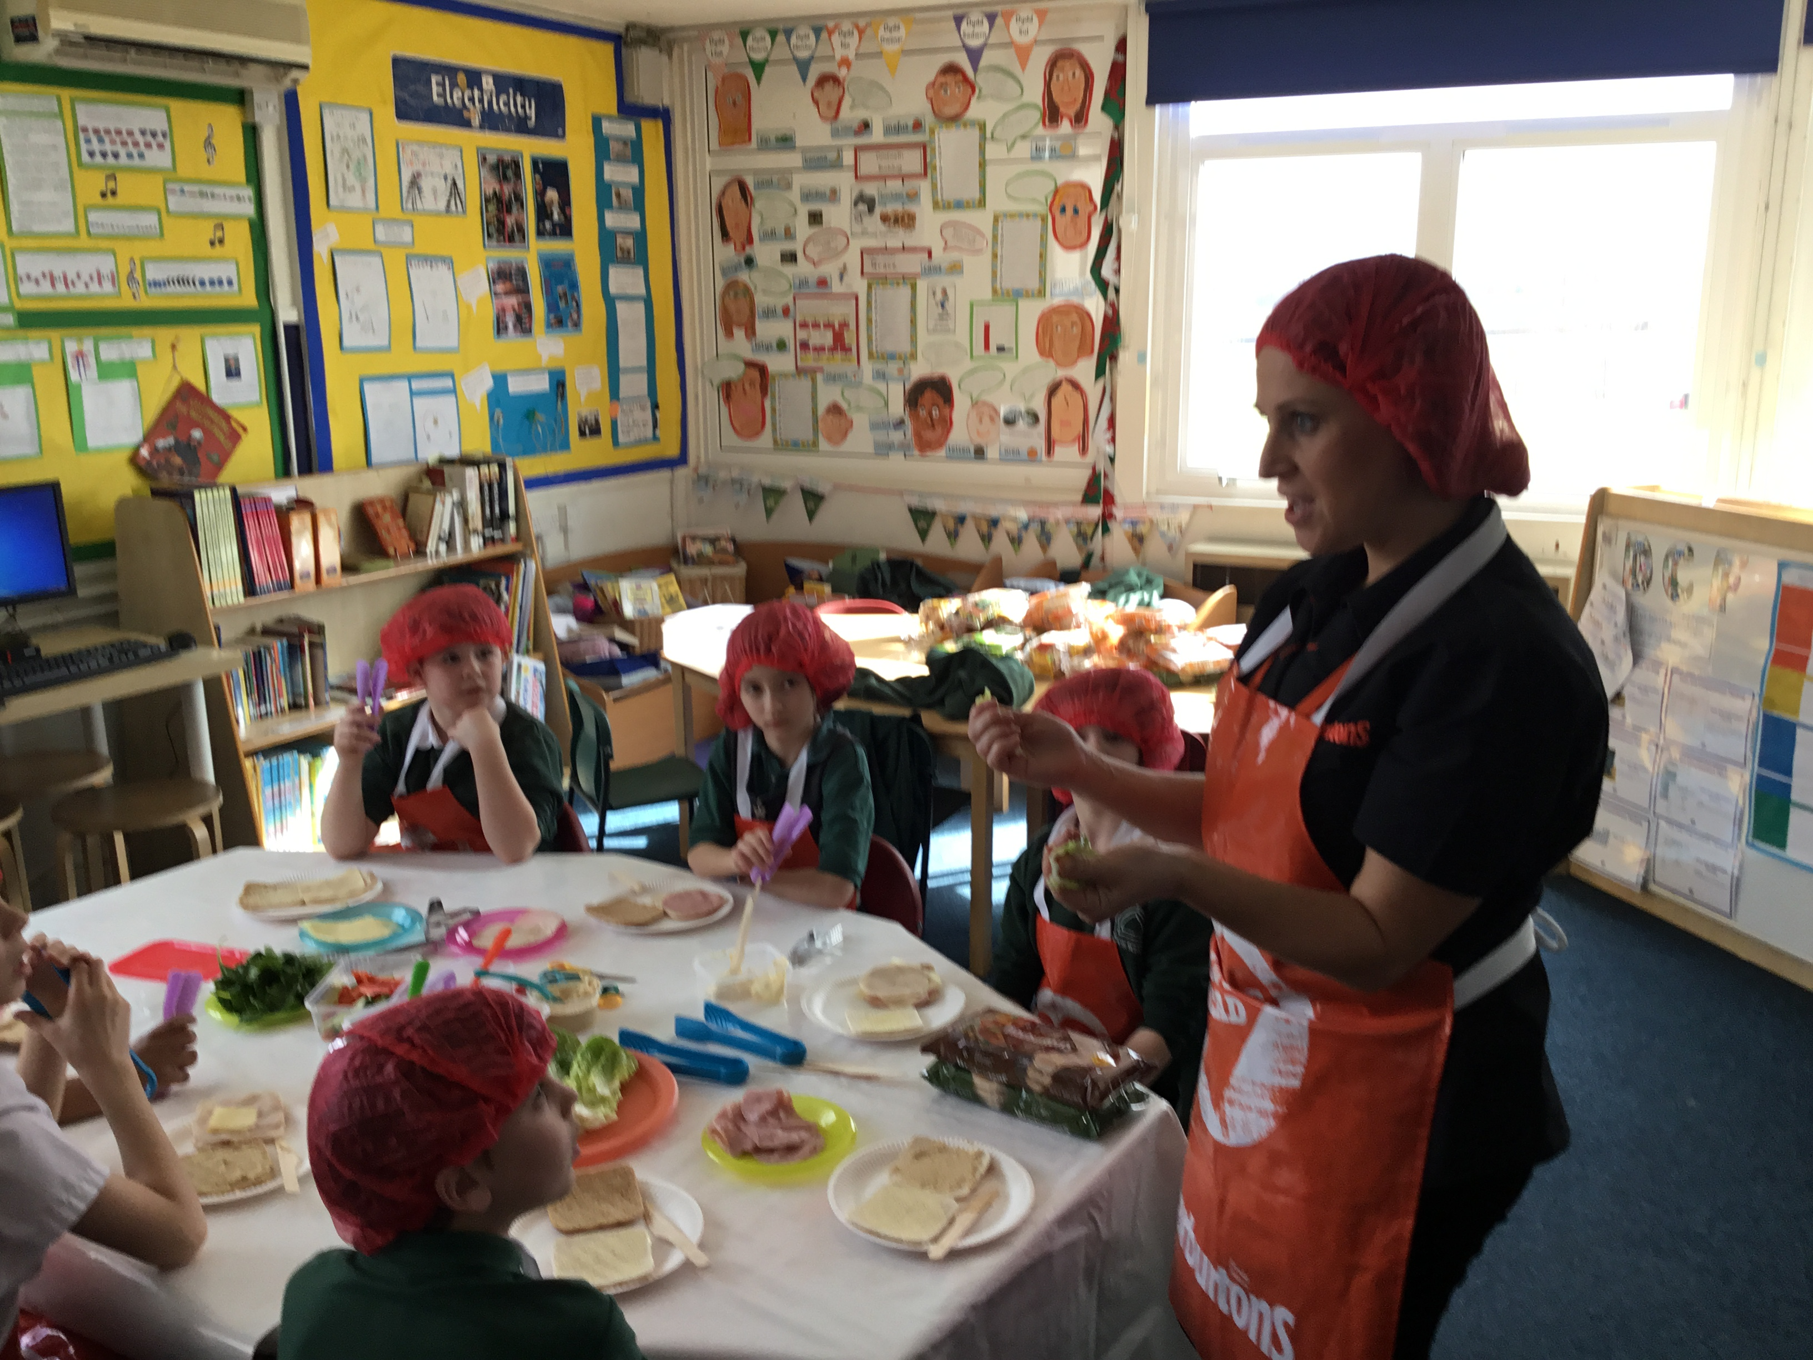
The children looked at the food groups on The Eatwell Plate.
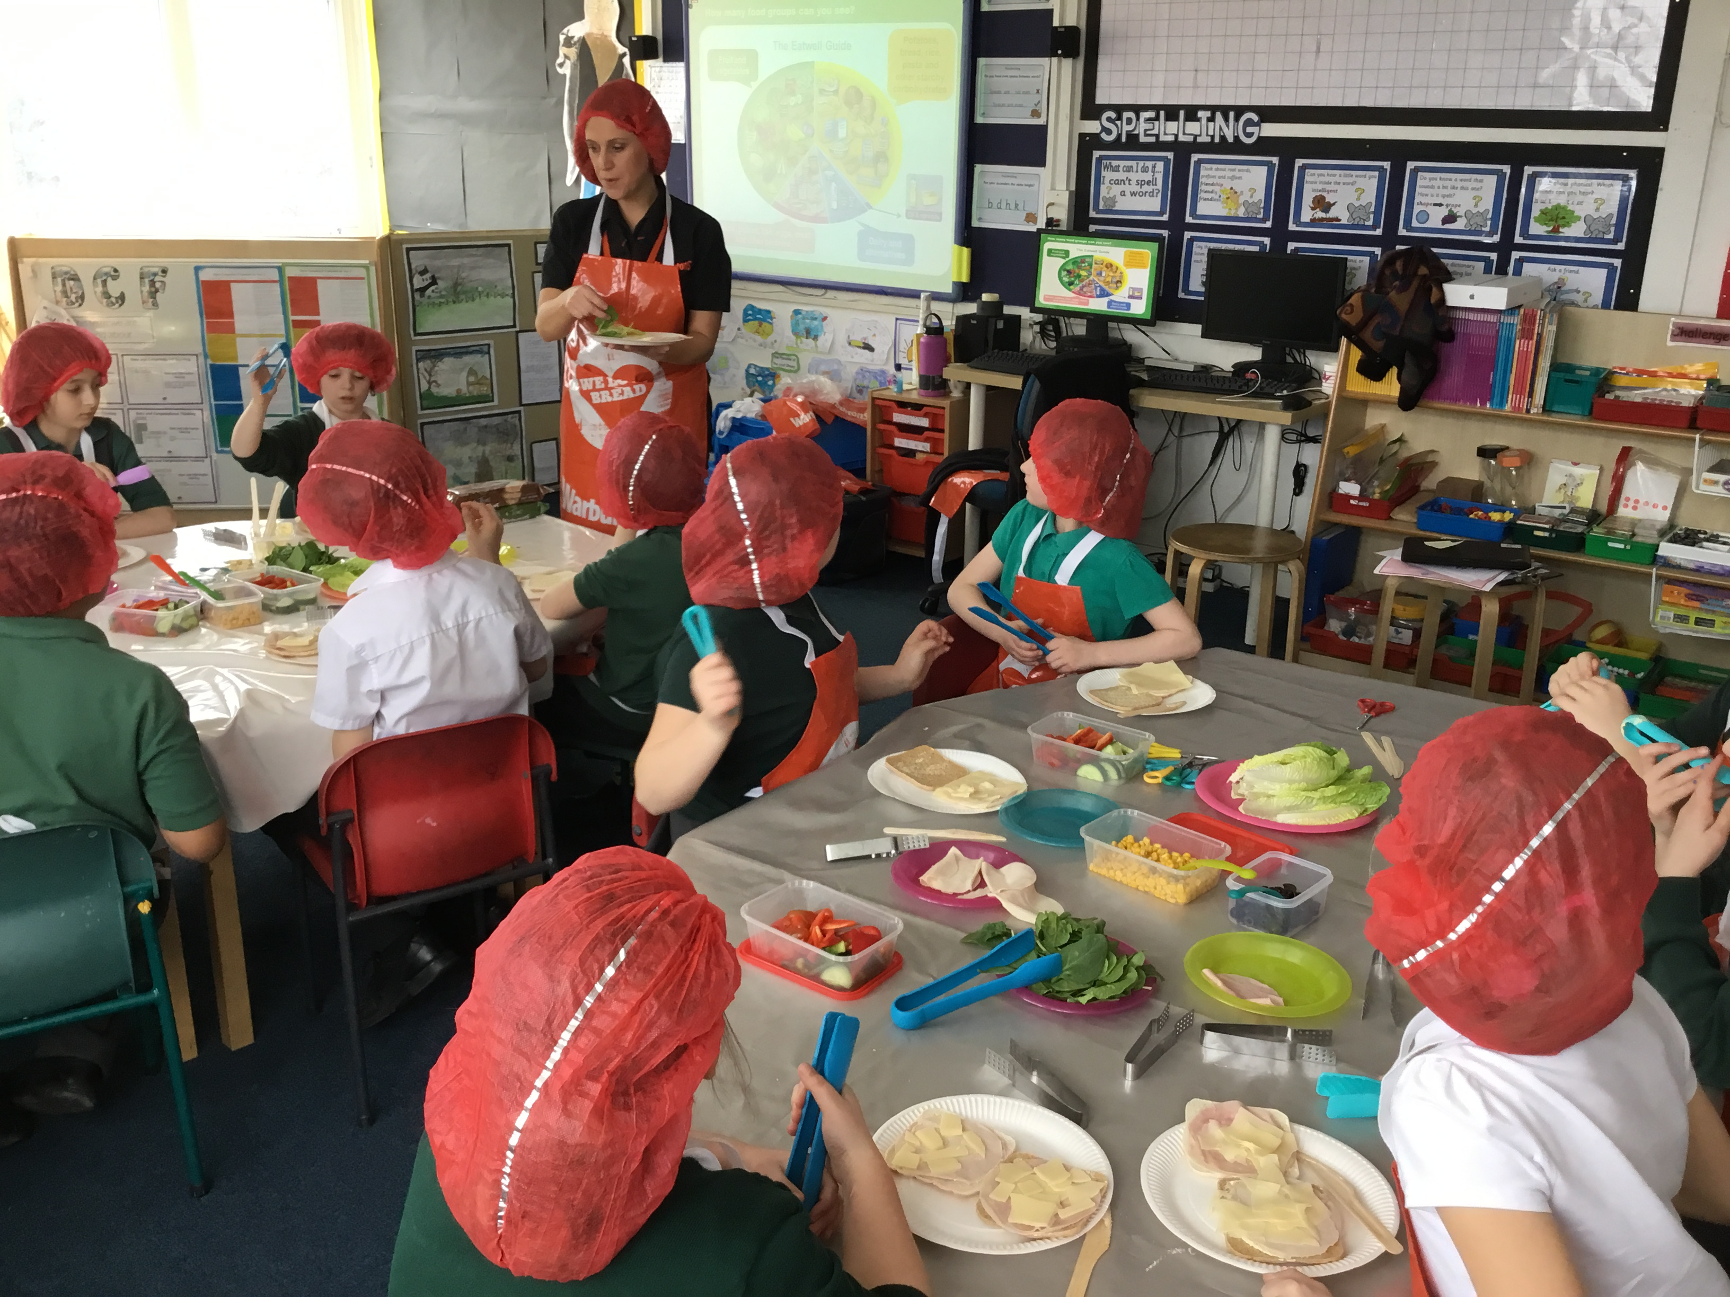

The children prepared healthy sandwiches…and took some delicious goodies home.
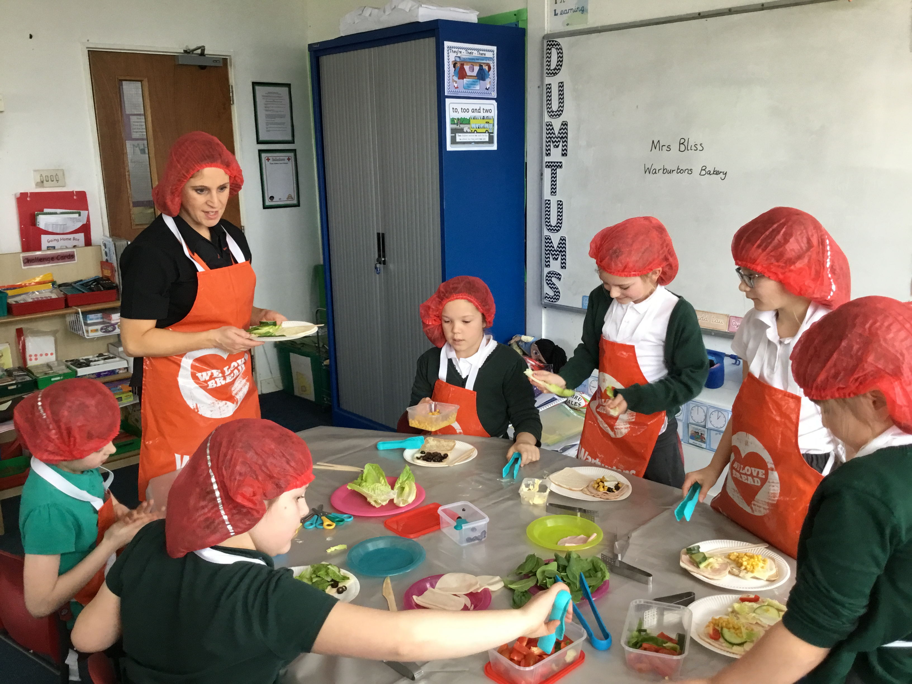
Thank you Warburtons and Mrs Bliss for a fantastic afternoon.

